

# 

### Semester Two Examination, 2019

### Question/Answer booklet

# MATHEMATICS

**SOLUTIONS**

**METHODS**

**UNITS 3 AND 4**

## Section Two:

## Calculator-assumed

|  |  |  |  |  |  |  |  |  |  |  |
| --- | --- | --- | --- | --- | --- | --- | --- | --- | --- | --- |
| Student number: In figures |  |  |  |  |  |  |  |  |  |  |

In words

Your name

## Time allowed for this section

Reading time before commencing work: ten minutes

Working time: one hundred minutes

## Materials required/recommended for this section

***To be provided by the supervisor***

This Question/Answer booklet

Formula sheet (retained from Section One)

***To be provided by the candidate***

Standard items: pens (blue/black preferred), pencils (including coloured), sharpener,  
correction fluid/tape, eraser, ruler, highlighters

Special items: drawing instruments, templates, notes on two unfolded sheets of A4 paper, and up to three calculators approved for use in this examination

## Important note to candidates

No other items may be taken into the examination room. It is **your** responsibility to ensure that you do not have any unauthorised material. If you have any unauthorised material with you, hand it to the supervisor **before** reading any further.

## Structure of this paper

|  |  |  |  |  |  |
| --- | --- | --- | --- | --- | --- |
| Section | Number of questions available | Number of questions to be answered | Working  time (minutes) | Marks available | Percentage of examination |
| Section One:  Calculator-free | 8 | 8 | 50 | 52 | 35 |
| Section Two:  Calculator-assumed | 13 | 13 | 100 | 98 | 65 |
|  | | |  | **Total** | 100 |

## Instructions to candidates

1. The rules for the conduct of examinations are detailed in the school handbook. Sitting this examination implies that you agree to abide by these rules.

2. Write your answers in this Question/Answer booklet preferably using a blue/black pen.  
Do not use erasable or gel pens.

3. You must be careful to confine your answer to the specific question asked and to follow any instructions that are specified to a particular question.

4. Show all your working clearly. Your working should be in sufficient detail to allow your answers to be checked readily and for marks to be awarded for reasoning. Incorrect answers given without supporting reasoning cannot be allocated any marks. For any question or part question worth more than two marks, valid working or justification is required to receive full marks. If you repeat any question, ensure that you cancel the answer you do not wish to have marked.

5. It is recommended that you do not use pencil, except in diagrams.

6. Supplementary pages for planning/continuing your answers to questions are provided at the end of this Question/Answer booklet. If you use these pages to continue an answer, indicate at the original answer where the answer is continued, i.e. give the page number.

7. The Formula sheet is not to be handed in with your Question/Answer booklet.

Section Two: Calculator-assumed 65% (98 Marks)

This section has**thirteen (****13)** questions. Answer **all** questions. Write your answers in the spaces provided.

Working time: 100 minutes.

Question 9 (6 marks)

The graph of $y=f(x)$, where $f(x)=4\log_{e}{(x-a)}$, has a root at $x=4$.

(a) Determine the value of the constant $a$ and hence state the equation of the asymptote of the graph. (2 marks)

|  |
| --- |
| **Solution** |
| $$x-a=1⇒a=4-1=3$$ Asymptote is $x=3$. |
| **Specific behaviours** |
| ✓ determines value of $a$ ✓ equation of asymptote |

(b) Determine the exact coordinates of the point on the graph where $f^{'}\left(x\right)=\begin{matrix}1 \\ \overline{4}\end{matrix}$. (3 marks)

|  |
| --- |
| **Solution** |
| $$f^{'}\left(x\right)=\frac{4}{x-3}$$ $$\frac{4}{x-3}=\frac{1}{4}⇒x=19$$ $$y=4\ln{(19-3)}=4\ln{16}=4\ln{2^{4}}=16\ln{2}$$ At $(19, 16\ln{2})$. |
| **Specific behaviours** |
| ✓ indicates $f^{'}\left(x\right)$ ✓ solves for $x$ ✓ exact coordinates |

(c) The graph of $y=f(x)$ is congruent with the graph of $y=\log_{e}{g(x)}$. State a suitable function $g(x)$. (1 mark)

|  |
| --- |
| **Solution** |
| $$g\left(x\right)={\left(x-3\right)}^{4}$$ |
| **Specific behaviours** |
| ✓ correct function (accept translations) |

Question 10 (6 marks)

A machine is set to fill bottles with more than the stated capacity. The random variable $X$ mL is the amount it overfills bottles and has probability density function $f\left(x\right)$ shown below.

$$f\left(x\right)=\left\{\begin{matrix}\frac{3\sqrt{2x-2}}{8} & & 1≤x≤3 \\ & & \\ 0 & & \text{otherwise}\end{matrix}\right.$$

(a) Determine $E(X)$. (2 marks)

|  |
| --- |
| **Solution** |
| $$\int_{1}^{3}{x∙f\left(x\right)}dx=\frac{11}{5}=2.2 \text{mL}$$ |
| **Specific behaviours** |
| ✓ correct integral  ✓ correct mean |

(b) Determine $\operatorname{Var}{(X)}$. (2 marks)

|  |
| --- |
| **Solution** |
| $$\int_{1}^{3}{{\left(x-\frac{11}{5}\right)}^{2}∙f\left(x\right)}dx=\frac{48}{175}≈0.2743 {\text{mL}}^{2}$$ |
| **Specific behaviours** |
| ✓ correct integral  ✓ correct variance |

(c) The amount another machine overfills bottles is given by $Y=2+0.5X$. Determine

(i) $E(Y)$. (1 mark)

|  |
| --- |
| **Solution** |
| $$2+0.5\left(\frac{11}{5}\right)=\frac{31}{10}=3.1 \text{mL}$$ |
| **Specific behaviours** |
| ✓ correct mean |

(ii) $\operatorname{Var}{(Y)}$. (1 mark)

|  |
| --- |
| **Solution** |
| $${\left(0.5\right)}^{2}×\frac{48}{175}=\frac{12}{175}≈0.0686 {\text{mL}}^{2}$$ |
| **Specific behaviours** |
| ✓ correct variance |

Question 11 (6 marks)

A water tank sprung a leak. The amount of water $W$ remaining in the tank $t$ minutes after the leak began can be modelled by the equation $W=30e^{-kt}$ kilolitres, where $k$ is a constant.

$3.5$ kL of water was lost from the tank in the first $10$ minutes.

(a) Determine the value of $k$. (2 marks)

|  |
| --- |
| **Solution** |
| $$30-3.5=30e^{-10k}$$ $$k=0.0124$$ |
| **Specific behaviours** |
| ✓ substitutes values into equation  ✓ solves for $k$ |

(b) How many kilolitres of water leaked from the tank during the first $2$ hours? (2 marks)

|  |
| --- |
| **Solution** |
| $$W\left(120\right)=30e^{-0.0124\left(120\right)}$$ $$=6.77$$ $30-6.77=23.23$ kL leaked. |
| **Specific behaviours** |
| ✓ amount remaining  ✓ amount leaked |

(c) At what time, to the nearest minute, was the instantaneous rate of water loss 186 litres per minute? (2 marks)

|  |
| --- |
| **Solution** |
| $$\frac{dW}{dt}=-0.186=-0.0124W$$ $$W=15$$ $$15=30e^{-0.0124t} \\ t=55.9≈56 \text{minutes}$$ |
| **Specific behaviours** |
| ✓ calculates amount of water  ✓ solves for $t$ |

Question 12 (6 marks)

An opinion poll found that $160$ out of $386$ people supported a policy to increase the minimum wage, from which a $95\%$ approximate confidence interval for the population proportion was calculated to be

$$(0.366, 0.464)$$

(a) Show how this interval was calculated. (4 marks)

|  |
| --- |
| **Solution** |
| $$\hat{p}=\frac{160}{386}≈0.4145$$ $$σ_{\hat{p}}=\sqrt{\frac{\left(0.4145\right)\left(1-0.4145\right)}{386}}≈0.0251$$ $$z_{0.95}≈1.96 \\ E=1.96×0.0251≈0.0491$$ $$0.4145±0.0491=\left(0.3654, 0.4636\right)≈(0.366, 0.464)$$ |
| **Specific behaviours** |
| ✓ indicates proportion  ✓ indicates standard deviation  ✓ uses $z$-score for $95\%$ to determine margin of error  ✓ uses margin of error to obtain interval |

(b) If $15$ similar opinion polls were taken and each time a $95\%$ confidence interval calculated, determine the probability that all $15$ intervals contain the true population proportion.

(2 marks)

|  |
| --- |
| **Solution** |
| Let the rv $X$ be the # of intervals containing the true proportion, then $X\sim B\left(15, 0.95\right)$ $$P\left(X=15\right)=0.4633$$ |
| **Specific behaviours** |
| ✓ indicates distribution with parameters  ✓ correct probability |

Question 13 (9 marks)

The time taken to answer a customer call at a large business can be modelled by the continuous random variable $T$ that is uniformly distributed between $7$ and $32$ seconds.

(a) Sketch a diagram of the associated probability density function for $T$. (3 marks)

|  |
| --- |
| **Solution** |
|  |
| **Specific behaviours** |
| ✓ indicates scale on $y$-axis  ✓ indicates endpoints on $x$-axis  ✓ horizontal line segment |

(b) Determine $P\left(T>23 \right| T<28)$. (2 marks)

|  |
| --- |
| **Solution** |
| $$P=\frac{P(23<T<28)}{P(T<28)}=\frac{28-23}{28-7}=\frac{5}{21}$$ |
| **Specific behaviours** |
| ✓ indicates correct method  ✓ correct probability |

(c) A simulation involves taking a random sample from the uniform distribution, recording the time and repeating a total of $500$ times. The times are then grouped into $5$ equal width classes, from which a frequency histogram is constructed.

(i) Sketch a likely histogram on the axes below. (3 marks)

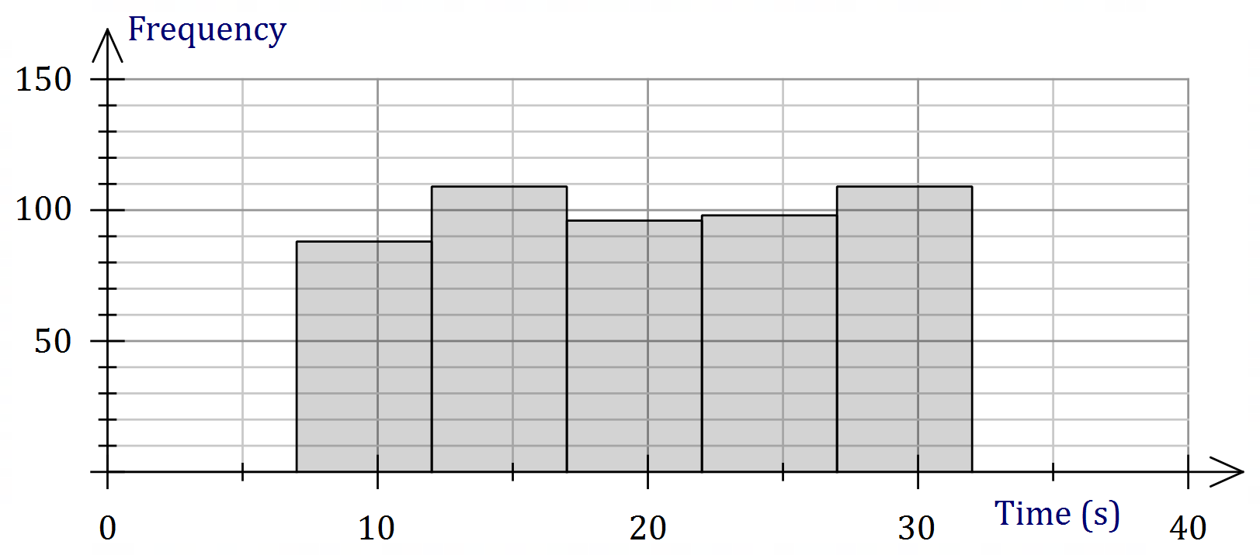

|  |
| --- |
| **Solution** |
| See graph. |
| **Specific behaviours** |
| ✓ horizontal scale and intervals  ✓ vertical scale  ✓ columns with slight height variations |

(ii) Briefly explain how your sketch would change if the simulation was repeated a second time. (1 mark)

|  |
| --- |
| **Solution** |
| Would expect about the same again, but with slightly different frequencies in each class. |
| **Specific behaviours** |
| ✓ reasonable explanation |

Question 14 (8 marks)

The table below shows the probability distribution for a random variable $X$.

|  |  |  |  |  |
| --- | --- | --- | --- | --- |
| $$x$$ | $$0$$ | $$1$$ | $$2$$ | $$3$$ |
| $$P(X=x)$$ | $$2k^{2}+2k$$ | $$k^{2}$$ | $$2k^{2}+k$$ | $$k$$ |

(a) Determine the value of the constant $k$. (2 marks)

|  |
| --- |
| **Solution** |
| $$2k^{2}+2k+k^{2}+2k^{2}+k+k=1$$ $$5k^{2}+4k-1=0$$ $$\left(5k-1\right)\left(k+1\right)=0⇒k=\frac{1}{5}$$ |
| **Specific behaviours** |
| ✓ sums probabilities to $1$ ✓ solves equation for $k$ |

(b) Determine $E\left(X\right)$ and $\operatorname{Var}{(X)}$. (3 marks)

|  |
| --- |
| **Solution** |
| $$P\left(X=0\right)=\frac{12}{25}, P\left(X=1\right)=\frac{1}{25}, P\left(X=2\right)=\frac{7}{25}, P\left(X=3\right)=\frac{5}{25},$$ $$E\left(X\right)=\frac{6}{5}=1.2, \operatorname{Var}\left(X\right)=\frac{38}{25}=1.52$$ |
| **Specific behaviours** |
| ✓ evaluates probabilities  ✓ correct mean  ✓ correct variance |

(c) Given that $E\left(aX+b\right)=5$ and $\operatorname{Var}\left(aX+b\right)=38$, determine all possible values of the constants $a$ and $b$. (3 marks)

|  |
| --- |
| **Solution** |
| Using variance: $\frac{38}{25}×a^{2}=38⇒a=±5$ Using mean: $5\left(\frac{6}{5}\right)+b=5⇒b=-1$ or $-5\left(\frac{6}{5}\right)+b=5⇒b=11$ $$\left\{a=5, b=-1\right\}\text{ or }\left\{a=-5, b=11\right\}$$ |
| **Specific behaviours** |
| ✓ one value for $a$ ✓ one value for $b$ ✓ all possible solutions |

Question 15 (8 marks)

It is known that $80\%$ of a large population of animals carry microfilariae in their blood (are carriers). A student must simulate selecting animals that either are or are not carriers.

(a) Describe a method that the student could use. (2 marks)

|  |
| --- |
| **Solution** |
| Examples  Use 5-sided spinner marked 1-5: 1-4 is carrier, 5 is not carrier.  Use dice: 1-4 is carrier, 5 is not carrier, 6 ignore.  Use random number generator, balls in hat, etc, etc. |
| **Specific behaviours** |
| ✓ describes method  ✓ indicates how long-term success of $80\%$ is achieved |

(b) The random variable $X$ is the number of animals in a random sample of size $200$ that are carriers. Describe the distribution of $X$ and determine $E(X)$. (2 marks)

|  |
| --- |
| **Solution** |
| $$X\sim B\left(200, 0.8\right)$$ $$E\left(X\right)=200×0.8=160$$ |
| **Specific behaviours** |
| ✓ distribution with parameters  ✓ expected value |

$225$ students carry out the simulation so that they each have a sample of size $200$. Then each student calculates $\hat{p}$, the proportion of animals in their sample that are carriers. The distribution of these $225$ values of $\hat{p}$ will be approximately normal.

(c) Determine the parameters of the normal distribution the $225$ values of $\hat{p}$ will approximate. (2 marks)

|  |
| --- |
| **Solution** |
| $$μ=0.8$$ $$σ^{2}=\frac{0.8\left(1-0.8\right)}{200}=\frac{1}{1250}=0.0008 (σ≈0.0283)$$ |
| **Specific behaviours** |
| ✓ mean  ✓ variance (or sd) |

(d) Briefly describe how the closeness of the normal approximation would change if

(i) the sample size was larger. (1 mark)

|  |
| --- |
| **Solution** |
| Becomes closer. ( $np(1-p)$ increases) |
| **Specific behaviours** |
| ✓ indicates closer |

(ii) the percentage of animals that are carriers was higher. (1 mark)

|  |
| --- |
| **Solution** |
| Becomes less close. ( $np(1-p)$ decreases as $p$ moves away from $0.5$) |
| **Specific behaviours** |
| ✓ indicates less close |

Question 16 (8 marks)

The graph of $y=f\left(x\right)$ is shown below.

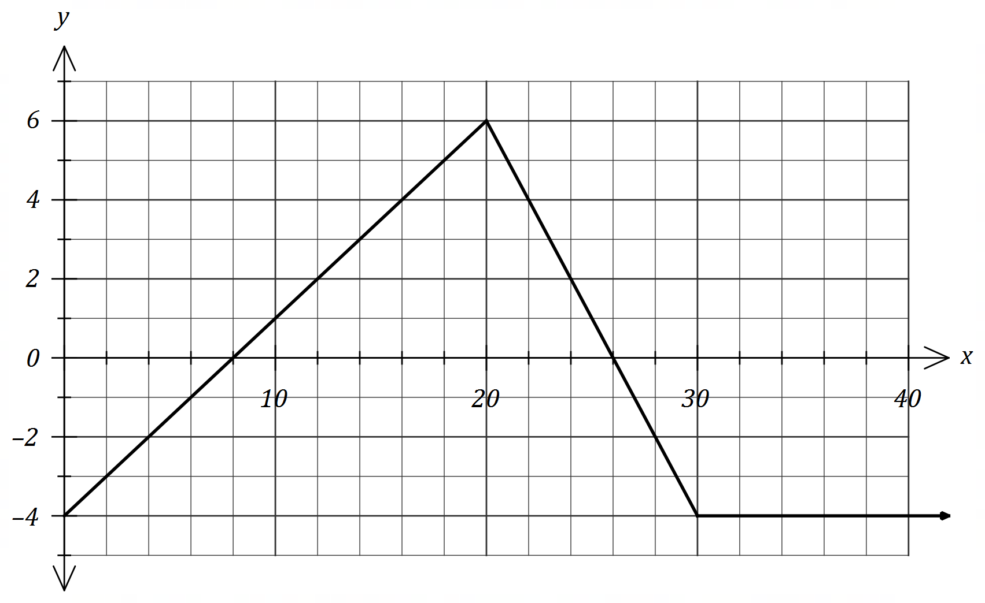

(a) Determine $\int_{4}^{14}{\underset{ }{\overset{ }{f(x)}}}dx$. (2 marks)

|  |
| --- |
| **Solution** |
| $$\frac{1}{2}\left(6\right)\left(3\right)+\frac{1}{2}\left(4\right)\left(-2\right)=9-4=5$$ |
| **Specific behaviours** |
| ✓ uses difference of areas  ✓ correct value |

Let $A\left(x\right)=\int_{0}^{x}{\underset{ }{\overset{ }{f(t)}}}dt$.

(b) Determine

(i) $A(8)$. (1 mark)

|  |
| --- |
| **Solution** |
| $$\frac{1}{2}\left(8\right)\left(-4\right)=-16$$ |
| **Specific behaviours** |
| ✓ correct value |

(ii) $A'(8)$. (1 mark)

|  |
| --- |
| **Solution** |
| $$A^{'}\left(8\right)=f\left(8\right)=0$$ |
| **Specific behaviours** |
| ✓ correct value |

(c) Determine the coordinates of the maximum of the graph of $y=A(x)$. (2 marks)

|  |
| --- |
| **Solution** |
| Maximum at $x=26$. $A\left(26\right)=\frac{1}{2}\left(18\right)\left(6\right)-16=54-16=38$ .  At $(26, 38)$. |
| **Specific behaviours** |
| ✓ -coordinate  ✓ correct coordinates |

(d) Determine the root of the graph of $y=A(x)$ for $x>16$. (2 marks)

|  |
| --- |
| **Solution** |
| $$A\left(k\right)=0$$ $$38+\frac{1}{2}\left(4\right)\left(-4\right)+(k-30)\left(-4\right)=0⇒k=37.5$$ Root when $x=37.5$. |
| **Specific behaviours** |
| ✓ one root  ✓ both roots |

Question 17 (7 marks)

When seen from above, an evaporation tank of area m2 has the shape of rectangle $ABDE$ and semicircle $BCD$ of radius $r$.

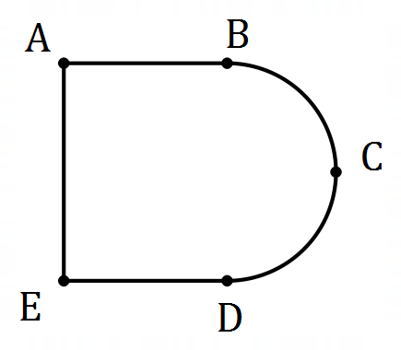

(a) If length $AB=x$, express $x$ in terms of $r$ and hence show that the perimeter, $P$ m, of the tank is given by (3 marks)

$$P=\frac{320}{r}+2r+\frac{πr}{2}$$

|  |
| --- |
| **Solution** |
| $$A=320=2rx+\frac{{πr}^{2}}{2}⇒x=\frac{160}{r}-\frac{πr}{4}$$ $$P=πr+2r+2x \\ =πr+2r+2\left(\frac{160}{r}-\frac{πr}{4}\right) \\ =\frac{320}{r}+2r+\frac{πr}{2}$$ |
| **Specific behaviours** |
| ✓ expression for area  ✓ transposes for $x$ ✓ substitutes into expression for perimeter |

(b) Use a calculus method to determine the minimum perimeter of the tank. (4 marks)

|  |
| --- |
| **Solution** |
| $$\frac{dP}{dx}=-\frac{320}{r^{2}}+2+\frac{π}{2}$$ $$\frac{dP}{dx}=0⇒r^{2}=\frac{640}{4+π}⇒r=\frac{8\sqrt{10}}{\sqrt{π+4}} (≈9.467)$$ $$P_{MIN}=8\sqrt{10π+40} \text{m }(≈67.6 \text{m})$$ |
| **Specific behaviours** |
| ✓ computes first derivative  ✓ solves equal to zero  ✓ chooses positive root  ✓ correct minimum perimeter |

Question 18 (7 marks)

A citrus farm grows Eureka lemons. Their weights are normally distributed with a mean of $172$ g and a standard deviation of $8.6$ g.

(a) Determine the probability that

(i) a randomly chosen lemon has a weight that exceeds $175$ g. (1 mark)

|  |
| --- |
| **Solution** |
| $$P\left(W>175\right)=0.3636$$ |
| **Specific behaviours** |
| ✓ correct probability |

(ii) in a random sample of $12$ lemons, exactly $4$ have a weight that exceeds $175$ g.

(2 marks)

|  |
| --- |
| **Solution** |
| $$X\sim B\left(12, 0.3636\right)$$ $$P\left(X=4\right)=0.2328$$ |
| **Specific behaviours** |
| ✓ indicates distribution with parameters  ✓ correct probability |

The farm classifies their lemons by size, so that the ratio of the number of small to medium to large lemons is $1 :2 :4$.

(b) Determine the upper and lower bounds for the weight of a medium sized lemon. (2 marks)

|  |
| --- |
| **Solution** |
| $$P\left(W<l\right)=\frac{1}{7}⇒l=162.8 \text{g}$$ $$P\left(W<u\right)=\frac{3}{7}⇒u=170.5 \text{g}$$ Hence $162.8≤w≤170.5 \text{g}$ |
| **Specific behaviours** |
| ✓ indicates correct method  ✓ correct bounds |

(c) Determine the probability that when lemons are picked at random, the first small lemon is chosen on the th pick. (2 marks)

|  |
| --- |
| **Solution** |
| $$P={\left(\frac{6}{7}\right)}^{4}\left(\frac{1}{7}\right)=\frac{1296}{16807}≈0.0771$$ |
| **Specific behaviours** |
| ✓ indicates correct method  ✓ correct probability |

Question 19 (9 marks)

A particle moves along the $x$-axis with initial position $x(0)=3.2$ m and velocity $v(0)=1.2$ m/s.

The acceleration of the particle after $t$ seconds is given by m/s2.

Between $t=1$ and $t=4$ the particle undergoes a change in displacement of $51$ m.

(a) Determine the value of the constant $m$. (4 marks)

|  |
| --- |
| **Solution** |
| $$v\left(t\right)=\int{a\left(t\right)}dt \\ =mt-0.1t^{2}+1.2$$ $$Δx=\int_{1}^{4}{v\left(t\right)}dt \\ =7.5m+1.5$$ $$7.5m+1.5=51⇒m=6.6$$ |
| **Specific behaviours** |
| ✓ expression for velocity  ✓ expression for $Δx$ ✓ evaluates $Δx$ ✓ correct value |

(b) Determine

(i) the maximum velocity of the particle. (2 marks)

|  |
| --- |
| **Solution** |
| $$a\left(t\right)=0⇒6.6-0.2t=0⇒t=33$$ $$v\left(33\right)=6.6\left(33\right)-0.1{\left(33\right)}^{2}+1.2=110.1 \text{m/s}$$ |
| **Specific behaviours** |
| ✓ solves $a=0$ for $t$ ✓ correct velocity |

(ii) the distance of the particle from the origin after $6$ seconds. (3 marks)

|  |
| --- |
| **Solution** |
| $$Δx=\int_{0}^{6}{v\left(t\right)}dt=118.8$$ $$x(6)=118.8+3.2=122 \text{m}$$ |
| **Specific behaviours** |
| ✓ indicates method  ✓ change in displacement  ✓ correct distance |

Question 20 (9 marks)

Researchers in a large city wish to determine a $90\%$ confidence interval for $p$, the proportion of citizens who had used the city library at least once during the previous year. The margin of error of the interval is to be no more than $5\%$.

(a) If the researchers had no reliable estimate for $p$, determine the sample size they should take, noting **all** assumptions made. (5 marks)

|  |
| --- |
| **Solution** |
| $$z_{90\%}=1.645, E=0.05, p=0.5$$ $$n=\frac{{1.645}^{2}\left(0.5\right)\left(0.5\right)}{{0.05}^{2}}=271$$ Assumed that:  1. $p=0.5$ for conservative estimate.  2. Sample will be a simple random sample of citizens.  3. Sample is large enough so that the sampling distribution is close approximation to a normal distribution. |
| **Specific behaviours** |
| ✓ uses correct parameters  ✓ calculates sample size  ✓ notes assumed value for $p$ ✓ notes need for a random sample  ✓ notes need for large enough sample |

(b) The researchers were given access to data from a random sample of $159$ citizens collected a few years earlier. Of these, $59$ had used the city library at least once during the previous year.

(i) Determine the margin of error for a $90\%$ confidence interval for $p$ based on this sample. (2 marks)

|  |
| --- |
| **Solution** |
| $$z_{90\%}=1.645, n=159, \hat{p}=59÷159=0.371$$ $$E=1.645\sqrt{\frac{0.371(1-0.371)}{159}}=0.063$$ |
| **Specific behaviours** |
| ✓ uses correct parameters  ✓ calculates margin of error |

(ii) The researchers used this data to decrease the sample size calculated in part (a). By how much did the sample size decrease? (2 marks)

|  |
| --- |
| **Solution** |
| $$n=\frac{{1.645}^{2}\left(0.371\right)\left(1-0.371\right)}{{0.05}^{2}}=253$$ Decrease is $271-253=18$ |
| **Specific behaviours** |
| ✓ new sample size  ✓ decrease |

Question 21 (9 marks)

The population of a species $P$ can be modelled by the equation $P=ab^{t}$, where $a$ and $b$ are constants and $t$ is the number of years since the population was first recorded. The graph below shows the linear relationship between $t$ and $\log_{10}{P}$ for the population over the past $90$ years and passes through the points $(0, 4)$ and $(89, 4.5)$.

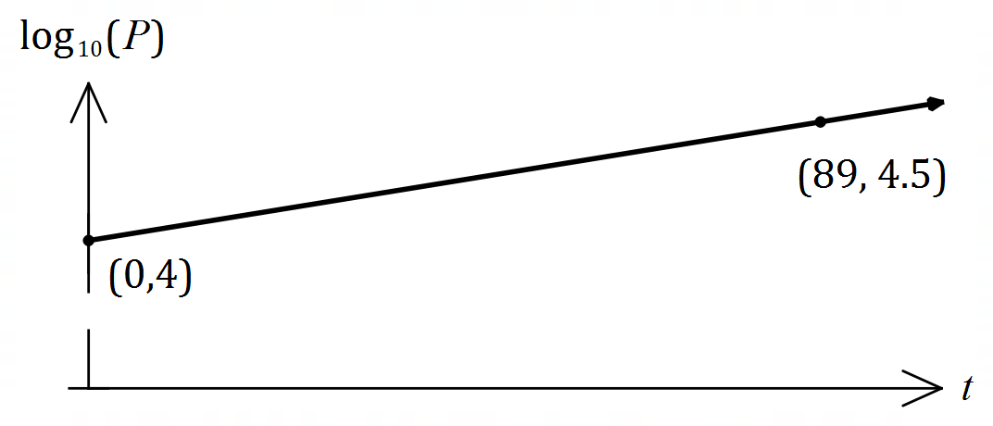

(a) Write an equation relating $\log_{10}{P}$ and $t$. (2 marks)

|  |
| --- |
| **Solution** |
| $$\frac{4.5-4}{89-0}=\frac{1}{178}$$ $$\log_{10}{P}=\frac{1}{178}t+4$$ |
| **Specific behaviours** |
| ✓ gradient  ✓ equation |

(b) Determine the value of $a$ and the value of $b$. (3 marks)

|  |
| --- |
| **Solution** |
| $$P=ab^{t}⇒\log_{10}{P}=\log_{10}{a}+t\log{b}$$ $$\log_{10}{a}=4⇒a={10}^{4}=10 000$$ $$\log_{10}{b}=\frac{1}{178}⇒b={10}^{\left(\frac{1}{178}\right)}≈1.013$$ |
| **Specific behaviours** |
| ✓ forms log equation  ✓ value of $a$ ✓ value of $b$ |

(c) Interpret the value of $a$ and the value of $b$ in the context of this model. (2 marks)

|  |
| --- |
| **Solution** |
| $a=10 000$ represents the initial population $b≈1.013$ is the growth constant - the population is growing by approximately $1.3\%$ per year. |
| **Specific behaviours** |
| ✓ interpretation for  ✓ interpretation for $b$ that includes annual growth rate |

(d) Use the model to determine

(i) the population when $t=45$. (1 mark)

|  |
| --- |
| **Solution** |
| $$P=10000{\left(1.013\right)}^{55}≈17 900$$ |
| **Specific behaviours** |
| ✓ correct value |

(ii) the number of years for the population to reach $75 000$. (1 mark)

|  |
| --- |
| **Solution** |
| $$75000=10000{\left(1.013\right)}^{t}$$ $$t≈156 \text{years}$$ |
| **Specific behaviours** |
| ✓ number of years |

Supplementary page

Question number: _________

Supplementary page

Question number: _________

© 2019 WA Exam Papers. Kennedy Baptist College has a non-exclusive licence to copy and communicate this document for non-commercial, educational use within the school. No other copying, communication or use is permitted without the express written permission of WA Exam Papers. SN245-145-4.